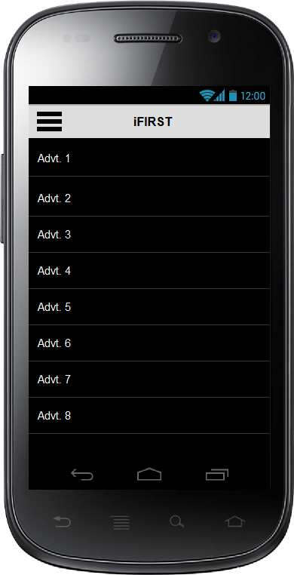**List of Advertisement**

* Here User can see list of Advertisement by its Registered Department.
* User can pick any advertisement to view details.

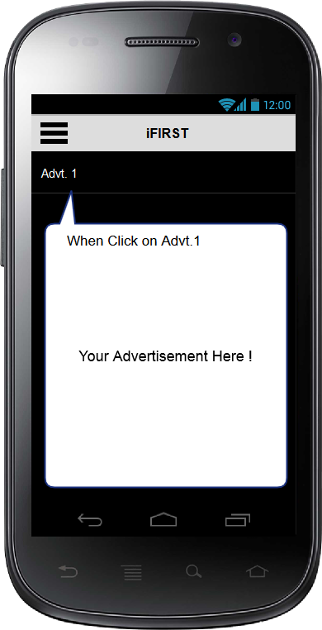

**Advertisement’s Views.**

Here Advertisement is play till and shows

* Image
* Audio
* Video

Automatically log is created that User’s see particular Advertisement.

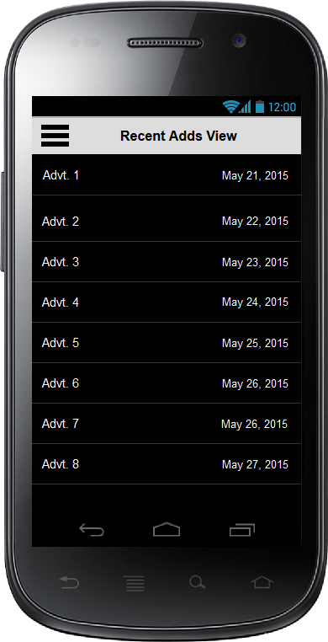

**List of Recent Views Advertisements.**

* Here user sees List of Recently open advertisement with date.